**Big Data HW8 Graph Partitioning**

In my homework I have used vertex cut, edge cut, greedy vertex cut and hybrid cut. I have used the small-5. graph and roadNet-PA.graph to output the necessary partitions into a text file as asked from our assignment.

Example:

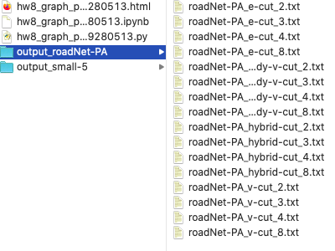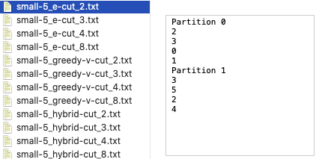

I have only managed to do the 80 points part. I tried the same code as well as modifying the code into parallel programming for the twitter data but still it was too slow because it was still computing after 1 day. Maybe because I have used python to do this task.

Vertex and edge cut were really simple to implement but hybrid was more complex but it computed much faster than the others. For me greedy vertex cut also was difficult to implement but wasn’t as fast as hybrid.

I have also managed to compute a visual graph of small-5. graph by using the networkx library in python.

Here are my visuals:

Note that the red edges represent the repeated edges.

